

Software Engineering I 2016 Fall

Personal Health Monitor

Report II

Group 4

Chenfan Xiao, Chengyao Wen, Jianing Xu, Xinyu Li, Yuwei Jiang

**Part 1**

**1. System Sequence Diagram**

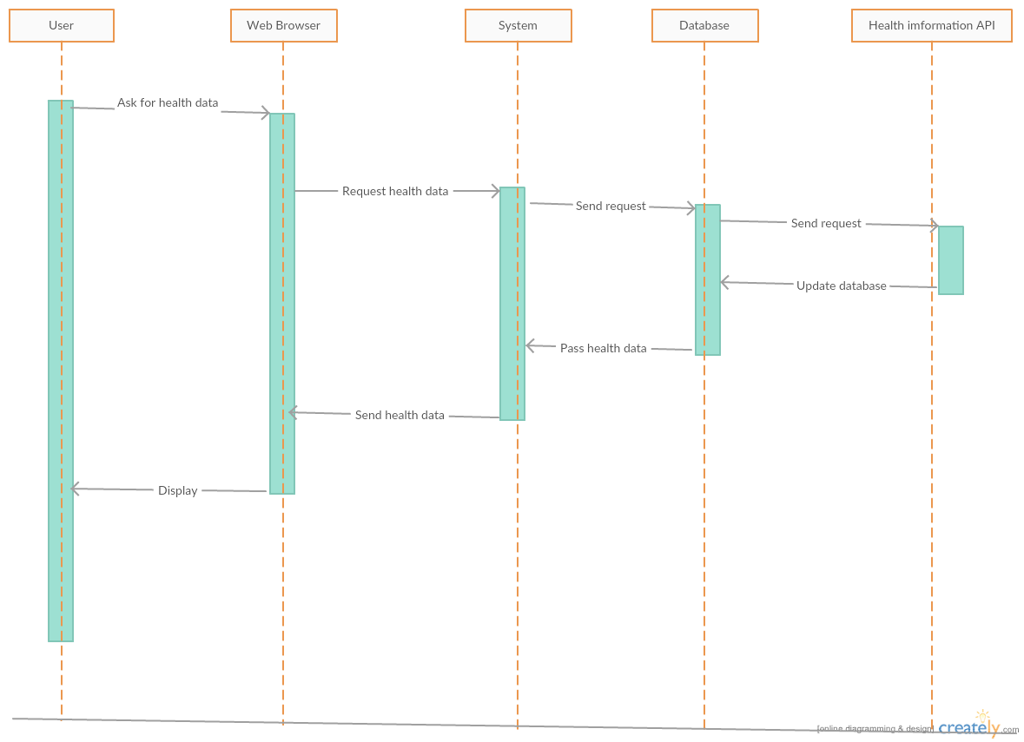

UC-1 Attain health data

This diagram describe the use case 1. When user wants to attain health information, the web browser sends the request to the system. Then system sends the request to the database, and database will get health information from the health data API. After update database, system could query the health data from database. Finally, system send this to the web browser and it will be displayed to the user.

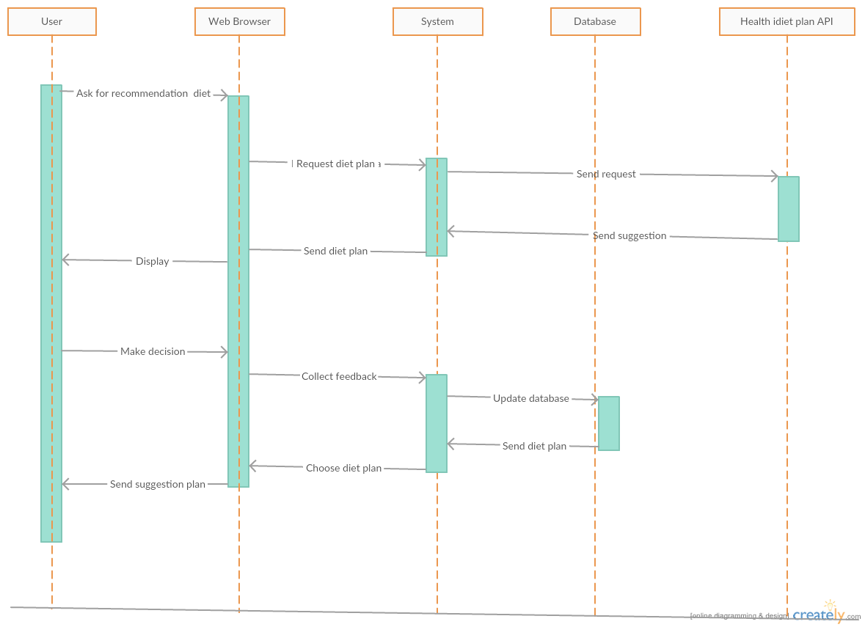

UC-3 Get Recommendation from the healthy diet

This diagram describe the use case 3. First, when user want to get some suggestions from system, the web browser will send this request to the system. Then system will ask health diet API to get a recommended diet plan, after this step, system can show this plan on the web browser. After the user decide whether to accept this suggestion, system can collect feedbacks of user’s decision and update the database. Finally, the system will show the last edition diet play to the user and record it.

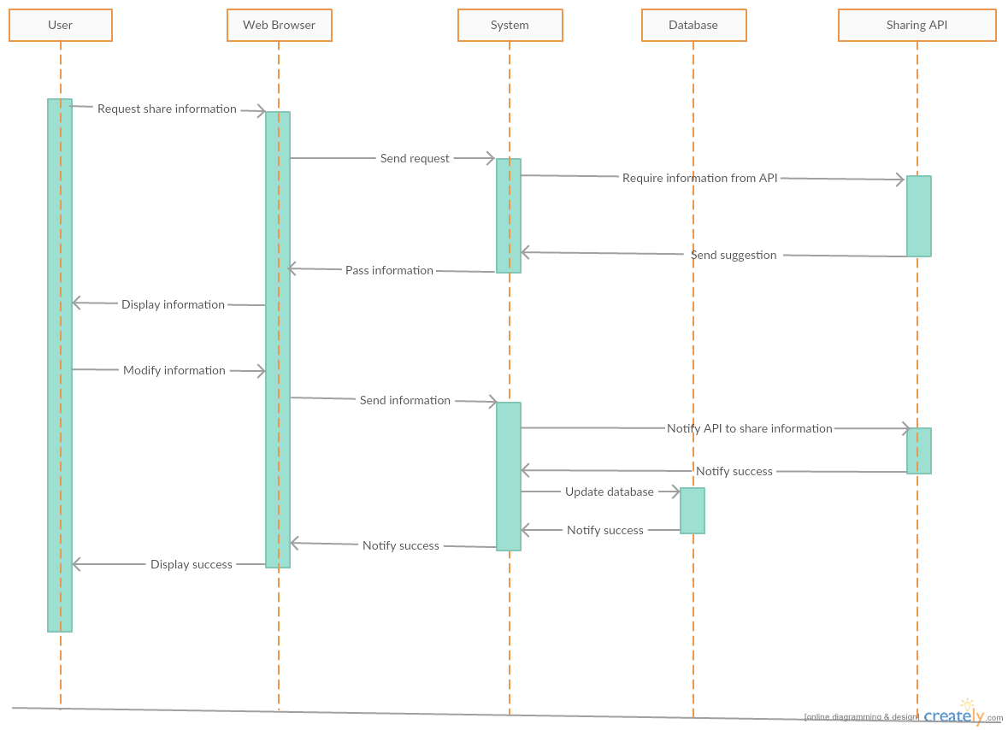

UC-6 Share the information to social website and invited friends

This diagram describe the use case 6. First, when user wants to share some health data or some useful informations to their friends, the web browser will get this request and send to the system. System will send this requirement to the suitable API and get the information from this API. The next step is system pass this information to the web browser and display to the user. After user modify the information and agree to share this information to others, system will send the new information to the API, and API will send them out. If The API successfully share this information, it will return a success signal. System will collect this signal and display to the user. Finally, user will be notified that they have already shared som information to his friends.

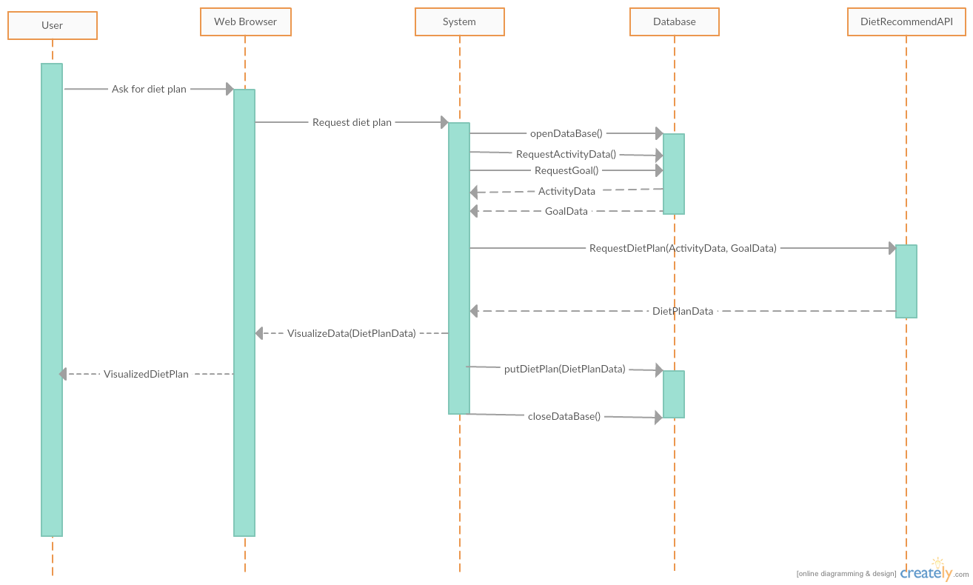

UC-8 Customize own diet plan

This diagram starts when user request for a diet plan. Then the browser send the request to System. The system will query in Database and get the Health Information ( Activity Data ) and User’s goal Data. Based on the data, System will send a request to our diet plan API with the data to request recommended diet plan. After getting the diet plan, the System will visualize the data and send to the browser to display to user. At the meanwhile, the system will store the diet plan data to the database in case the user would like to check in the future. The System will end when the data is stored in the database and it closes the database, and sends the data back to user, whichever is later.

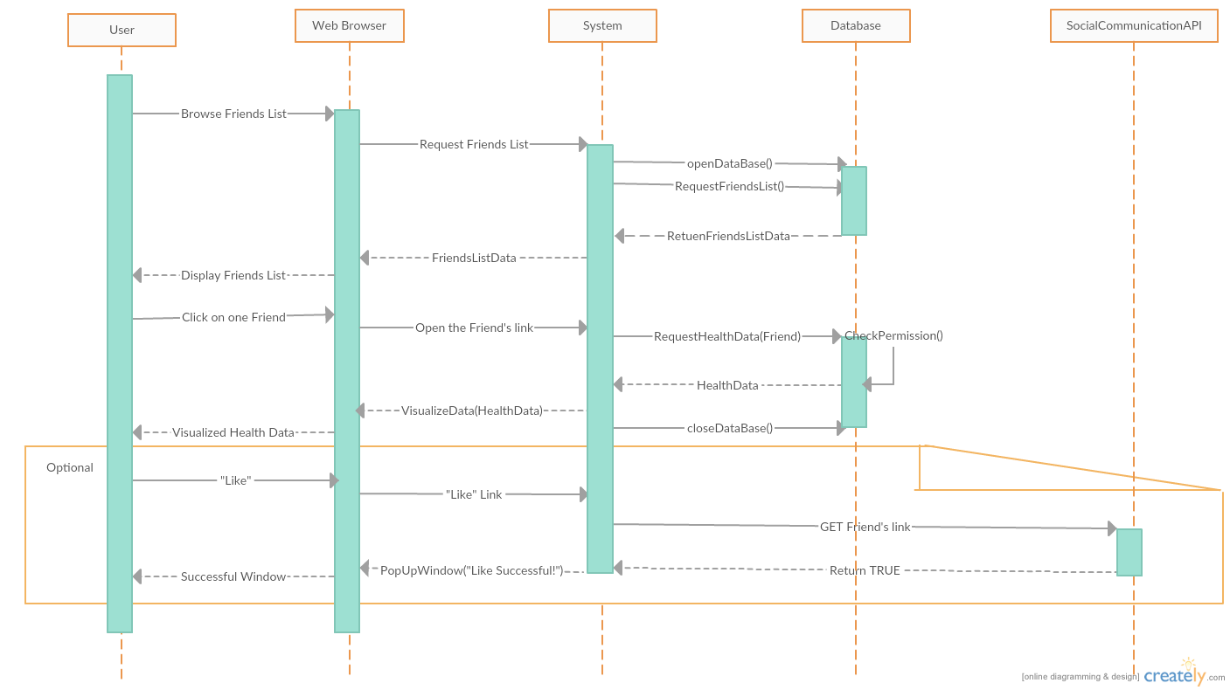

UC-9 View others health data and goal with permission

When the user enter into the friends page, which is the start of the System, the System would request Friends List from Database, then it would send the data to web browser to display. Then, the user can choose one friend, the web browser will use the link of the friend and send it to System. The system will request the Health Data from database. The database will first check if the user has the permission to read the health data, if so it will return the data. The System will use VisualizeData function to send it to user’s browser for displaying. If the user chooses to “Like” the friend’s data, the system will send the “like” request through API, if successful, the API will return true to the System. And the system will use the browser to pop-up a window indicating the “Like” operation is successful. The System will end after this.

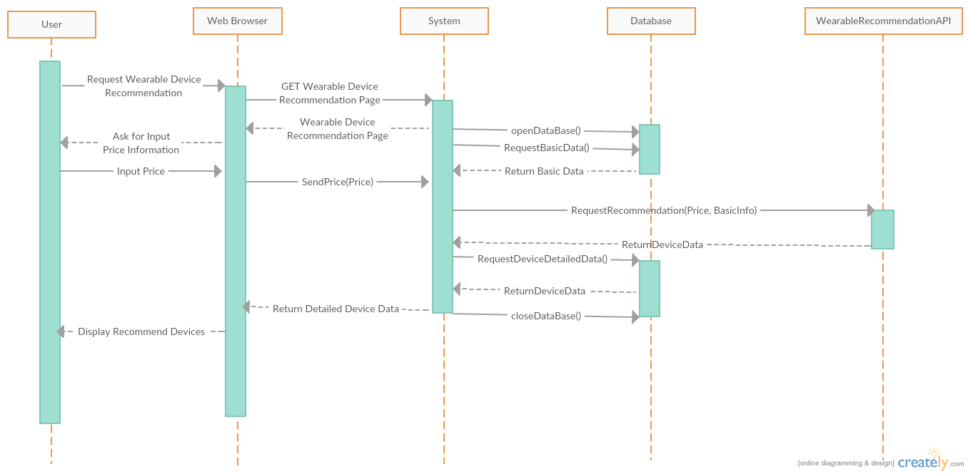

UC-11 Get a recommended wearable equipment

The System will start when the user enters into the wearable device recommendation page. The system will first request the basic data of the user, at the same time it will also ask the user to input the desired price of the wearable devices. Then the System will bundle the price and the basic data of the user and send it to the Wearable Device Recommendation API. The API will send back a list of devices to the System. The System will then send the devices with the details information stored in the Database to the User. The System will close the database after this. Then the System will end.

**2. Project Management**

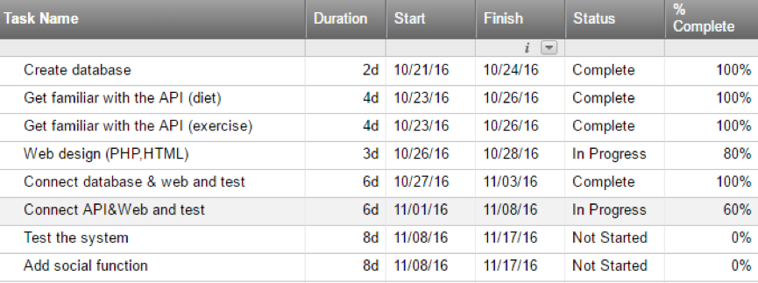

Project Breakdown

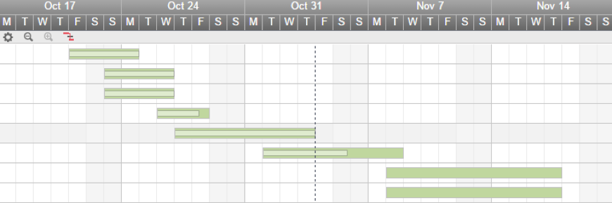

Project Schedule

Our project basically followed the plan we made. We installed the MySql to store the information and connected it with the web through php. At the meanwhile, we found the 2 APIs to use. One is the API to give suggestions about the diet based on the input information about the users, the other one is to give suggestions about the exercises to the users based on input information. Implementing these 2 API tend to be harder than we expected since not many APIs are open source, we either need to contact the owner of the API or to find some other API.

Since we have taken the Software Engineering 2 in the last semester, connecting the database and web is not difficult since we could use our experience in SE2, programing in php, MySql and html is almost completed, the only thing left is some appearance adjustments which could be done in near future. Compared with connection between web and database, the connection between web and API is much more difficult, the API we found is in C++ or Java, we need to convert it into php. Thus, there is still plenty of work to be done. Fortunately, we still have couple of days before the deadline we scheduled which is 11/08. After this process is finished, the majority of our project is completed and the remaining time could be used to test and improve our system. Some further functions might be added if possible.